Insights from Twitter: <https://marketing.twitter.com/en/success-stories/best-of-tweets-brand-bowl-lv>

1. How much was spent on ads in total? (AH)
   1. Does COVID have an impact on the willingness of brands to spend money on ads?
      1. Compare this year’s total ad spend with previous years’
      2. Compare this year’s number of advertisers with previous years
      3. <https://www.sportingnews.com/us/nfl/news/super-bowl-commercials-cost-2021/o496m61j4lkn19kxoygv9690a>

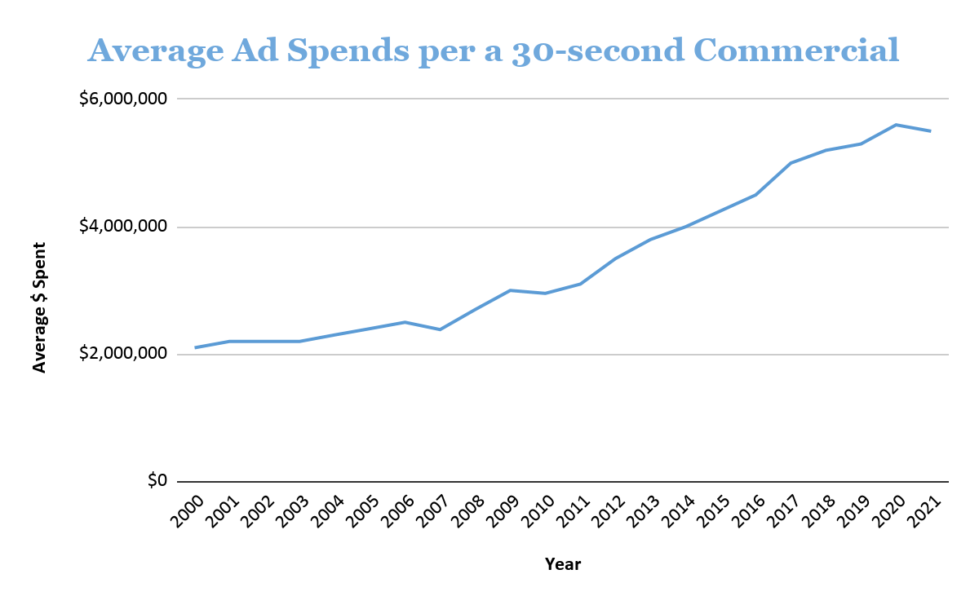

1. [There were 25 brands being first-time Super Bowl advertisers.](https://www.adweek.com/brand-marketing/every-super-bowl-55-ad-in-under-two-minutes/) (AH)
2. Correlation between # of ads 1 brand runs vs. # mentioned retweets? (AH)
   1. Find the number of times a brand runs ads and number of tweets mentioning the brand (Paramount, WeatherTech)
3. Ad spend v. response => ROI (AH)
   1. Find total [time length all of commercials](https://www.cnbc.com/2021/02/07/super-bowl-2021-commercials-live-coverage.html) from each brand, multiplied by $5.5 million/30 secs. [(done)](https://docs.google.com/spreadsheets/d/1soqohiOEM75FqgsZFnp8APpN2f6r8z6maiZrWzcsEcM/edit#gid=1218198908)
      1. Top 3 most expensive ads (in millions) are:
         1. Jeep | The Middle | $11.92 million
         2. Jimmy Johns | Meet the King | $9.90
         3. Bud Light Legends | $8.25
         4. Paramount Plus | Sweet Victory | $8.25
         5. CBS Clarice | $8.25
      2. Top 4 brands that spent the most:
         1. Paramount | $25.67
         2. Michelob | $17.42
         3. Bud light | $15.40
         4. Jeep | $11.92
      3. Top 5 most effective ads by $ thousands invested
         1. Disney - Falcon and Winter Soldier | $30
         2. Statefarm - Drake | $40
         3. CBS - Equalizer | $50
         4. T-mobile Rockstar | $120
         5. Cheetos - Cheetos Ranch | $220

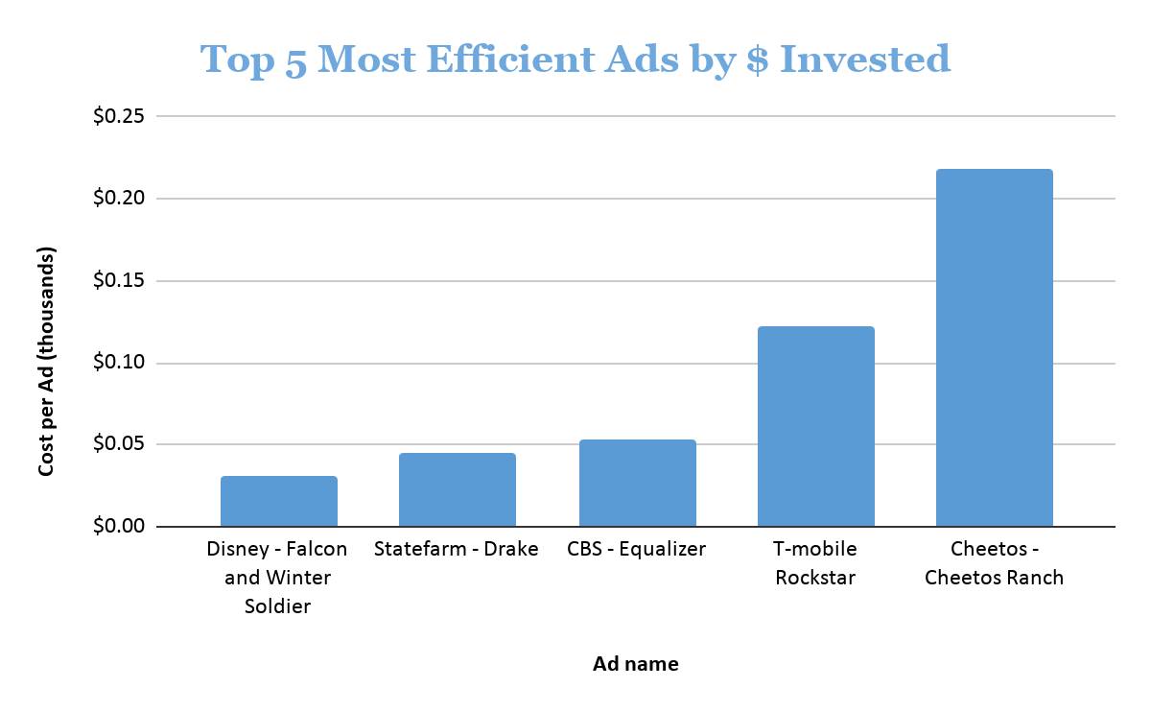

1. Sentimental analysis (DI)
   1. emojis?
2. Which brands are the most popular? (ZG)
   1. Find top 5 brands most mentioned in retweet=
      1. **Disney(Falcon and winter soldier) 179579**
      2. **T-mobile (Rockstar) 89984**
      3. **Statefarm(Drake) 61578**
      4. **CBS(Equalizer) 52211**
      5. **Cheetos(Wasn’t me) 25190**
         1. **Based on retweet count**
   2. 5 worst=
      1. **H&R Block(file free), 0**
      2. **Guaranteed Rate(underdog), 1**
      3. **Bass Pro Shop(Nature), 1**
      4. **CBS Sports (Masters), 5**
      5. **FBI Most Wanted (most wanted) 11**
      6. Recipe for the best and worst ads
3. What hashtag was most popular? (DI)
   1. Was the most popular hashtag linked to the most popular ad?
   2. Least popular hashtags?
      1. Trashtags
4. Top 5 Most Mentioned and Least Mentioned Brands by Unique Users:Sum all unique users tweeting brand-related terms
5. Most engaging ads by quarter? (DI) **based on retweet and favorite count**
   1. Input all ads into quarter category
   2. Highest tweet volume wins
6. Does the use of celebrities guarantee an ads success? (ZG)
   1. Separate ads into 2 categories: celebrities vs no celebrities
   2. Find average tweet volume of all ads
   3. Compare categories to average to determine if successful
   4. Insight: *“The Middle,” Jeep’s two-minute Super Bowl ad starring Bruce Springsteen, was pulled from YouTube after reports surfaced that Springsteen was arrested for a DWI in November*. [Adweek](https://www.adweek.com/brand-marketing/jeep-removes-springsteen-super-bowl-spot-from-youtube/?utm_content=lead&utm_source=postup&utm_medium=email&utm_campaign=FirstThingsFirst_Newsletter_210211055128&recip_id=1732247&lyt_id=1732247).
7. Which actor did fans love the most? (ZG)
   1. Based on tweet volume
8. Which actress did fans love the most? (ZG)
   1. Based on tweet volume
9. Most liked tweets? (DI)
10. Analysis of ads by categories (ZG)
    1. Separate ads into categories: food and drink, streaming service, physical product
    2. Look at tweet volume based on categories and determine winner
11. Which brand didn’t advertise but was mentioned a lot? (AH)
    1. Find tweets on other brands that didn’t advertise and number of tweets
       1. Budweiser, Pepsi
    2. What impact was felt due to the gap of Coke, Pepsi, and Budweiser? How often are they mentioned in our data?
       1. Other brands mentioned?
12. Geography (AH)
    1. Find where people tweeted the most
13. Demographic (AH)
    1. Age, gender
14. Are commercials with tweets sent by users with higher average followers likely to be more viral (high volume) or be higher in the Ad METER ranking?

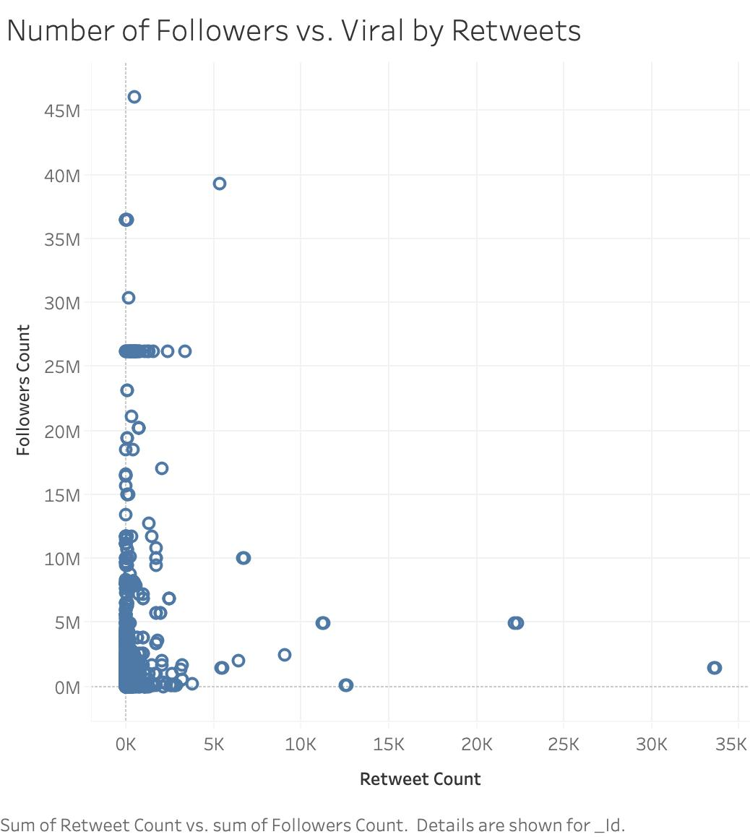

1. Did our data match field expert analysis of the ad? (ZG)

# [USA Today](https://www.usatoday.com/story/sports/Ad-Meter/2021/02/08/rocket-mortgage-best-super-bowl-commercial-top-spots-ad-meter/4427433001/) (AdMeter):

# 1. Rocket Mortgage wins best Super Bowl commercial in USA TODAY's Ad Meter.

* Disney (Falcon/Winter Soldier)

# 2. Rocket Mortgage took second place, too.

* T-Mobile (Rockstar)

# 3. Amazon finished third Sunday night with its ad [starring Michael B. Jordan as a seductive version of Alexa](https://www.usatoday.com/story/sports/Ad-Meter/Super-Bowl/2021/02/02/michael-b-jordan-stars-amazons-alexa-super-bowl-commercial/4292945001/)

* Statefarm (Drake)

# 4. M&M's humorous spot featuring Dan Levy was fourth.

* CBS (Equalizer)

# 5. [Toyota's moving ad about Paralympic swimmer Jessica Long](https://www.usatoday.com/story/sports/Ad-Meter/Super-Bowl/2021/02/03/jessica-long-takes-center-stage-toyotas-super-bowl-commercial/4292908001/) rounded out the top five.

* Cheetos (It Wasn’t Me)
  1. USA Today: Bottom 5:
     1. Oatly (Wow Wow No Cow)
        1. H&R Block
     2. Robinhood (We Are All Investors)
        1. Guaranteed Rate (Underdog)
     3. Mercari (Get Your Unused Things Back in the Game)
        1. Bass Pro Shop (Nature)
     4. Skechers (Tony Romo for Skechers Max Cushioning)
        1. CBS Sports (Masters)
     5. Klarna (The Four Quarter Sized Cowboys)
        1. FBI Most Wanted (most wanted)

Falon  
Statefarm

Cheetos

Jeep

****

* “Guarentee” was misspelled.
* Missing a few ads in the keyword files

1. Which ad was trending the soonest from its release?
   1. Look at time of ad release
   2. Look at volume of tweets within a time limit **(need to determine time limit)**
   3. Determines winner and why it's popular/loved
      1. Put hashtags from tweets into database to find what was most loved
2. Device
   1. What devices were used and how many people used each device?